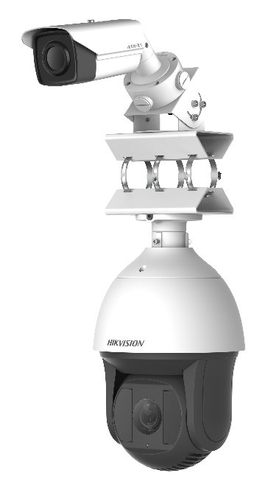
Hikvision DS-2TX3636-25P Thermal Smart Linkage Tracking Systems is formed by one fixed camera and one PTZ camera. The PTZ camera smartly tracks multiple moving targets, and the fixed camera offers the panoramic view. The linkage of both can be realized by the client software.
It provides you with smart detection of moving targets with up to 183 m effective detecting distance (to human targets), 1470 m effective detecting distance (to vehicle targets), and up to 30 targets can be tracked simultaneously.
The system mainly applies to major industrial infrastructures requiring perimeter prevention, such as: airport, prison, railway, museum, enterprise, high-end villas and others.

Features
- Leading image processing technology: Adaptive AGC, DDE, 3D DNR, NETD < 40mk (@25° C, F#=1.0)
- 384*288 resolution, high sensitivity sensor, support contrast adjustment
- 3D DNR, 15 palettes of color adjustable, image detail enhancement
- Speed Dome: Support 36x optical zoom with over 200m IR distance

Smart Function
- Smart analysis and linkage, no VCA Server configuration requirement
- Automatic master-slave Tracking: Stable and continuous tracking
- Manual master-slave tracking: Select any region of fixed camera in the client software, the speed dome automatically adjusts PTZ to centralize the selected region
- Master-slave Linkage Rules: Intrusion Detection, Line Crossing Detection
- 30 Targets Simultaneously Trackable. Up to 183 m effective detecting distance (to human targets)
- Multi-tracking targets and auto target switch, with less than 1s response time
- Tracking duration, sensitivity and target type can be configured

DS-2TX3636-25P
Thermal Smart Linkage Tracking System

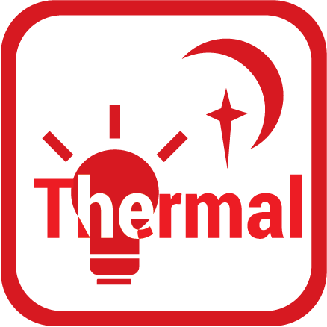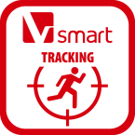

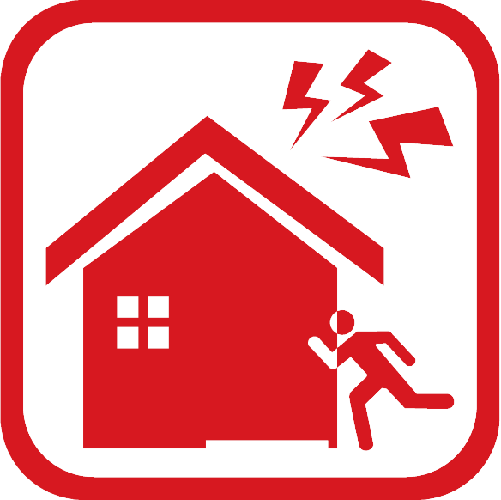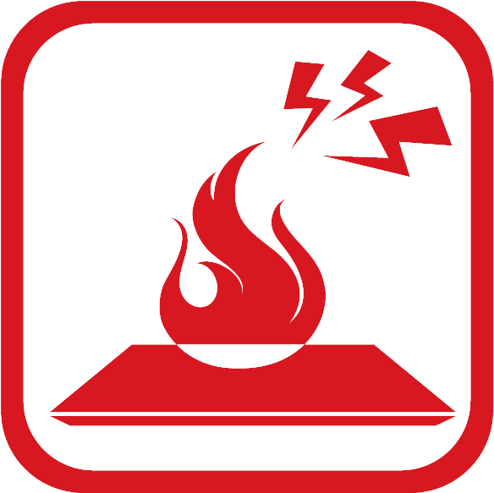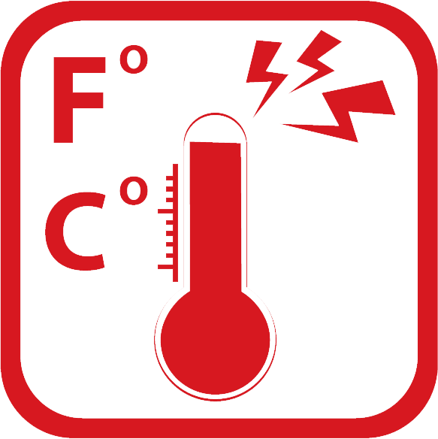
Specifications

Model | DS-2TX3636-25P
System Functions
Click Linkage | Support
Tracking Mode | Manual/Auto
Multi-targets Tracking | Up to 30 Targets Simultaneously; Up to 183 m effective detecting distance (to human targets), 1470 m effective detecting distance (to vehicle targets)
Switch Time | Less than 1s
Master-slave Linkage Rules | Support Intrusion Detection, Line Crossing Detection,
Tracking Time Configuration | Support
Sensitivity Configuration | Support
Fixed Camera
Image sensor | Vanadium Oxide Uncooled Focal Plane Arrays
Max. resolution | 384 × 288
Response waveband | 8μm to 14μm
NETD | < 40mk (@25°C,F#=1.0)
Lens (focal length) | 25 mm
IFOV (MRAD) | 0.68 mrad
Field of View | 14.88° × 11.19°
Min. focusing distance | 13 m
F number | 1.0
Main stream | 50fps (384×288)
Sub stream | 50fps (384×288)
Third stream | 50fps (384×288)
Video compression | H.264 (Baseline/Main/High Profile) /MJPEG/H.265, H.264+, H.265+
Audio compression | G .711u/G.711a/G.722.1/MP2L2/G.726/PCM
Memory Card | Built-in Micro SD card slot, support Micro SD/SDHC/SDXC card (up to 64G), support manual/alarm recording
Alarm input | 2-ch inputs (0-5vDC)
Alarm output | 2-ch relay outputs, alarm response actions configurable
Audio input | 1 3.5mm Mic in/Line in interface. Line input: 2-2.4V[p-p], output impedance:1KΩ±10%
Audio output | Line level, impedance: 600Ω
Analog video output | 1.0V[p-p] / 75Ω, PAL(or NTSC), BNC
Speed Dome
Image Sensor | 1/1.9” Progressive Scan CMOS
Min. Illumination | 50 IRE; Color: 0.002Lux @ (F1.5, AGC ON), B/W: 0.0002Lux @ (F1.5, AGC ON), 0 Lux with IR
Max. Image Resolution | 1920 × 1080
Focal Length | 5.7 to 205.2, 36×
Digital Zoom | 16 ×
Zoom Speed | Approx. 7.4s (Optical, Wide-Tele)
Angle of View | 58.7 ° to 2.0 ° (Wide-Tele)
Min. Working Distance | 10mm to 1500mm (Wide-Tele)
Aperture Range | F 1.5 to F 4.5
Focus Mode | Auto/Semiautomatic/Manual
WDR | 120dB
Shutter Time | 50 Hz: 1s to 30,000s; 60Hz: 1s to 30,000s
AGC | Auto/Manual
White Balance | Auto/Manual/ATW (Auto-tracking White Balance)/Indoor/Outdoor/Daylight Lamp/Sodium Lamp
Day & Night | IR cut filter
Privacy Mask | 24 programmable privacy masks
Optical Defog | Support
Enhancement | 3D DNR, EIS, HLC/BLC, SVC
Pan Speed | Manual Speed: 0.1°/s to 160°/s  Preset: 240°/s
Tilt Speed | Manual Speed: 0.1°/s to 120°/s  Preset: 200°/s
Main Stream | 50Hz: 25fps (1920 × 1080, 1280 × 960, 1280 × 720)  60Hz: 30fps (1920 × 1080, 1280 × 960, 1280 ×720)
Sub Stream | 50Hz: 25fps (704 × 576, 352 × 288, 176 × 144)  60Hz: 30fps (704 × 480, 352 × 240, 176 × 120)
Third Stream | 50Hz: 25fps (1920 × 1080, 1280 × 960, 1280 × 720, 704 × 576, 352 × 288, 176 × 144)  60Hz: 30fps (1920 × 1080, 1280 × 960, 1280 × 720, 704 × 480, 352 × 240, 176 × 120)
Image Compression | H.264 (Baseline/Main/High Profile)/MJPEG/MPEG4
Audio Compression | G.711alaw/G.711ulaw/G.722/G.726/MP2L2/ PCM
IR Distance | Up to 200m
Alarm Linkage | Preset, Patrol, Pattern, Micro SD/SDHC Card Recording, Aux Output, Notification on Client, FTP Uploading, Sending Email, Triggering Channel
Alarm Input | 7 –ch
Alarm Output | 2 –ch; Support Alarm Linkage
Audio Input | 1 LINE_IN Input and MIC Input; Peak: 2 to 2.4V [p-p]; Impedance: 1KΩ±10%
Audio Output | 1; Linear Level; Impedance: 600Ω
Ethernet | 10 Base-T/100 Base-TX. RJ45 Connector
On-board Storage | Built-in Micro SD/SDHC/SDXC Card Slot, Up to 128GB, Support Manual/Alarm Recording
Analog Video Output | 1.0V [p-p]/75Ω, PAL/NTSC/BNC
RS485 | Half-duplex; HIKVISION, PELCO-P, PELCO-D Self-adaptive
General
Movement Range | Network Camera (Universal Joint Module): Pan: 90°, Tilt: -45° to 45°  Speed Dome: Pan: 360°, Tilt: -20° to 90°, Auto Reverse
Menu | English
Power | 24 V AC/5A,  Max. consumption: 80W (with IR and heater on)  IR Light consumption: Max. 24 W, and Heater consumption: Max. 15 W
Working Temperature/Humidity | -40°C to 65°C (-40 °F to 149 °F); Humidity: 90% or Less
Protection Level | IP66, TVS 6000V Lightening Protection, Surging Protection and Voltage Transient Protection
Mount | Horizontal Pole Mount
Dimensions | Φ266.6 mm × 908.1 mm (Φ10.5” × 35.8”)
Weight | 12.89 kg (Approx. 28.4 lbs)

Wide Range Coverage for Different Specifications
Note: The table below is only for reference, the performance varies from model to model, and the specific data is based on 17 μm pixel space-between.
Lens (focal length) | 10mm | 15mm | 25mm | 35mm | 50mm | 75mm
Detection range (Vehicles) | 902m | 1353m | 2255m | 3157m | 4510m | 6765m
Detection range (Humans) | 294m | 441m | 735m | 1029m | 1471m | 2206m
Recognition range (Vehicles) | 225m | 338m | 564m | 789m | 1127m | 1691m
Recognition range (Humans) | 74m | 110m | 184m | 257m | 368m | 551m
Identification range (Vehicles) | 113m | 169m | 282m | 395m | 564m | 846m
Identification range (Humans) | 37m | 55m | 92m | 129m | 184m | 276m

Smart functions Range Table
Note: The table below is only for reference, the performance varies from model to model, and the specific data is based on 17 μm pixel space-between.
Lens (focal length) | 7mm | 10mm | 15mm | 25mm | 35mm | 50mm | 75mm
VCA range (humans) | 70m | 100m | 150m | 250m | 350m | 500m | 750m
VCA range (Vehicles) | 210m | 300m | 450m | 750m | 1050m | 1500m | 2250m
Temperature measurement  (Object:2×2 m) | 164m | 234m | 351m | 585m | 819m | 1170m | 1755m
Temperature measurement  ((Object:1×1 m) | 83m | 118m | 177m | 295m | 413m | 590m | 885m
Fire Detection (Object:2×2 m) | 412m | 588m | 882m | 1470m | 2058m | 2940m | 4410m
Fire Detection (Object:1×1 m) | 206m | 294m | 441m | 735m | 1029m | 1470m | 2205m

Order Models
DS-2TX3636-25P

Dimensions
0100001070413

