DS-2TD6266-50H2L
Thermal & Optical Bi-spectrum Network Positioning System
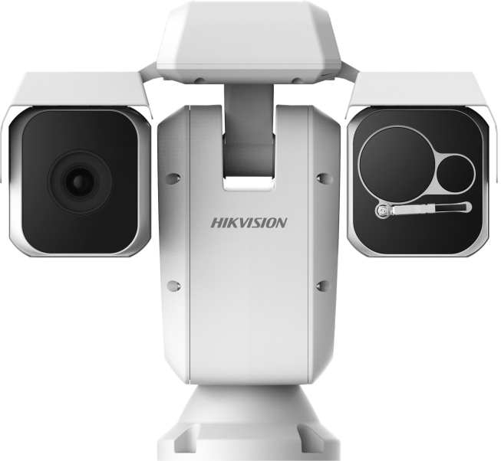
Hikvision DS-2TD6266-50H2L Thermal & Optical Bi-spectrum Network Positioning System is applied to frontier defense occasions, maritime defense occasions, port monitoring, airport perimeter security, and so on. The pre-alarm system helps you discover unexpected events immediately and protects you from property loss.

Smart Function (Thermal Imaging)
- Leading image processing technology: Adaptive AGC, DDE, 3D DNR, NETD < 40mk (@25°C, F#=1.0)
- Smart tracking: Panorama tracking, Event tracking and Multi-scene patrol tracking
- Smart tracking linkage: thermal view and optical view
- Powerful behavior analysis algorithm: Line crossing, Intrusion, Region Entrance & Exit
- Reliable temperature exception alarm function
- Advanced fire detection algorithm

Thermal Imaging Module Function
- 640*512 resolution, high sensitivity sensor, support contrast adjustment
- Support shutter adjustment in various modes
- 3D DNR, 15 palettes of color adjustable, image detail enhancement

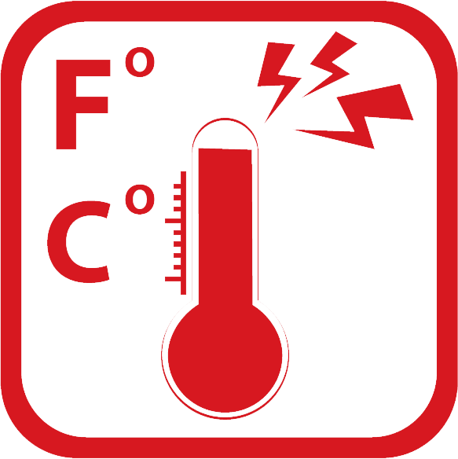

Specifications
Model  Parameter |  | DS-2TD6266-50H2L
 |  | Thermal & Optical Bi-spectrum Network Positioning System
Thermal module | Image sensor | Vanadium Oxide Uncooled Focal Plane Arrays
Thermal module | Max. Resolution | 640 × 512
Thermal module | Detector Pitch | 17μm
Thermal module | Response waveband | 8μm to 14μm
Thermal module | NETD | < 40mk(@25°C,F#=1.0)
Thermal module | Lens (focal length) | 50 mm
Thermal module | MRAD | 0.34 mrad
Thermal module | Field of View | 12.42° × 9.95°
Thermal module | Min. Focusing Distance | 7.5 m
Thermal module | F number | 1.0
Optical camera | Image Sensor | 1/1.9’’ Progressive Scan CMOS
Optical camera | Min. Illumination | Color: 0.002 lux @ (F1.5 , AGC On )  B/W : 0.0002 lux @ (F1.5 , AGC On )
Optical camera | Focal Length | 5.7-205.2mm, 36x
Optical camera | Digital Zoom | 16 X
Optical camera | Field of View | 58.7° - 2.0° (Wide-Tele)
Optical camera | Min. Working Distance | 10-1500mm (Wide-Tele)
Optical camera | Aperture Range | F1.5-F4.5
Optical camera | Focus Mode | Auto / Semiautomatic / Manual
Optical camera | WDR | 120dB
Optical camera | Shutter Time | PAL: 1-1/30,000s / NTSC: 1-1/30,000s
Optical camera | White Balance | Auto/Manual /ATW/Indoor/Outdoor/Daylight lamp/Sodium lamp
Optical camera | Day & Night | IR Cut Filter
Optical camera | Privacy Mask | 24 privacy masks programmable; optional multiple colors and mosaics
Optical camera | Optical Defog | Yes
Optical camera | Enhancement | 3D DNR
Smart function | VCA | Support 4 VCA rule types (Line Crossing, Intrusion, Region Entrance, and Region Exiting), 10 scenes and 8 VCA rules for each scene.
Smart function | Temperature Measurement | Support 3 temperature measurement rule types, over 256 presets as scene, 21 rules of each scene (10 points, 10 regions, and 1 line)
Smart function | Temperature range | -20 °C to 150 °C (-4 °C to 302 °F)
Smart function | Temperature accuracy | ± 8 °C (14.4 °F)
Smart function | Fire detection | Support 10 fire points
PTZ | Movement Range | Pan: 360° Continuous Rotate; Tilt: From -90° to + 40° (auto flip)
PTZ | Pan Speed | Configurable, From 0.1°/s to 110°/s
PTZ | Tilt Speed | Configurable, From 0.1°/s to 50°/s
PTZ | Proportional Zoom | Yes
PTZ | Presets | 300
PTZ | Patrol Scan | 8; Up to 32 Presets Per Patrol
PTZ | Pattern Scan | 4; More Than 10 Minutes Per Pattern
PTZ | Power Off Memory | Yes
PTZ | Park | Preset/Pattern Scan/Patrol Scan/Auto Scan/Tilt Scan/Random Scan/Frame Scan/Panorama Scan
PTZ | PT Status | Turn On/Turn Off
PTZ | Scheduled Task | Preset/Pattern Scan/Patrol Scan/Auto Scan/Tilt Scan/Random Scan/Frame Scan/Panorama Scan/Doom Reboot/Doom Adjust/Aux Output
Infrared | IR Distance | Up to 500m
Infrared | IR Intensity and Angle | Auto Adjust
Network | Main Stream | Optical Light: 50Hz:25fps (1920×1080), 25fps (1280×960), 25fps (1280×720)  Optical Light: 60Hz:30fps (1920×1080), 30fps (1280×960), 30fps (1280×720)  Thermal: 50fps (640 × 512)
Network | Sub stream | 50Hz:25fps (704 × 576), 25fps (352 × 288), 25fps (176 × 144)  60Hz:30fps (704 × 480), 30fps (352 × 240), 30fps (176 × 120)  Thermal: 50fps (640 × 512)
Network | Video compression | H.264 (Baseline/Main/High Profile) /MJPEG/MPEG4
Network | Audio compression | G .711u/G.711a/G.722.1/MP2L2/G.726/PCM
Network | Protocols | IPv4/IPv6,HTTP,HTTPS,802.1x,Qos,FTP,SMTP,UPnP,SNMP,DNS,DDNS,NTP,RTSP,RTCP,RTP,TCP,UDP,IGMP,ICMP,DHCP, PPPoE, Bonjour
Network | Simultaneous live view | Up to 20-ch
Network | User/Host level | Up to 32 users, 3 levels: Administrator, Operator, User
Network | Security measures | User authentication (ID and PW), MAC address binding, HTTPS encryption, IEEE 802.1x access control, IP address filtering
Integration | Alarm Input | Up to 7-ch Relay Input (0-5V DC)
Integration | Alarm Output | Up to 2-ch; Support Alarm Linkage
Integration | Alarm Action | Preset/Patrol Scan/Pattern Scan/SD Card Record/Relay Output/Smart capture/FTP upload/Email linkage
Integration | Audio Input | LINE_IN Input/MIC Input; Peak: From 2 to 2.4V[p-p]; Output Impedance: 1KΩ±10%
Integration | Audio Output | Linear Level; Impedance: 600Ω
Integration | Communication Interface | Built-in RJ45; 10M/100M Ethernet Interface
Integration | Onboard Storage | Built-in Micro SD/SDHC/SDXC Card Slot, Up to 64GB; Support Manual/Alarm Recording
Integration | Analog Video Output | 1.0V [p-p]/75Ω, PAL/NTSC/BNC
Integration | RS485 | Half-Duplex; HIKVISION, PELCO-P and PELCO-D Self-adaptive
Integration | API | Open-ended API, support ISAPI; Support HIKVISION SDK and Third-party Management Platform
Integration | Client | iVMS-4200
Integration | Web Browser | IE 7+, Chrome 18+, Firefox 5.0+, Safari 5.02+; Multiple Languages
General | Menu | English
General | Wiper | Yes
General | Power | 24V AC, 120W
General | Work Temperature/Humidity | From -40°C to 60°C (-40°F to 140°F); Humidity: 90% or Less
General | Protection Level | IP66 Standard; TVS 6000V Lightning Protection, Surge Protection and Voltage Transient Protection
General | Dimensions | 486.1 mm × 351.6 mm × 450.3 mm (19.14" × 13.84" × 17.73")
General | Weight | Approx. 19kg (41.89lb)

Wide Range Coverage for Different Specifications
Note: The table below is only for reference, the performance varies from model to model, and the specific data is based on 17 μm detector pitch.

Lens (focal length) | 7mm | 10mm | 15mm | 25mm | 35mm | 50mm | 75mm
Detection range (Vehicles) | 631m | 902m | 1353m | 2255m | 3157m | 4510m | 6765m
Detection range (Humans) | 206m | 294m | 441m | 735m | 1029m | 1471m | 2206m
Recognition range (Vehicles) | 158m | 225m | 338m | 564m | 789m | 1127m | 1691m
Recognition range (Humans) | 51m | 74m | 110m | 184m | 257m | 368m | 551m
Identification range (Vehicles) | 79m | 113m | 169m | 282m | 395m | 564m | 846m
Identification range (Humans) | 26m | 37m | 55m | 92m | 129m | 184m | 276m

Smart functions Range Table
Note: The table below is only for reference, the performance varies from model to model, and the specific data is based on 17 μm detector pitch.
Lens (focal length) | 7mm | 10mm | 15mm | 25mm | 35mm | 50mm | 75mm
VCA range (humans) | 50m | 72m | 110m | 183m | 255m | 360m | 540m
VCA range (Vehicles) | 144m | 205m | 308m | 514m | 720m | 1029m | 1544m
Temperature measurement  (Object:2×2 m) | 164m | 234m | 351m | 585m | 819m | 1170m | 1775m
Temperature measurement  ((Object:1×1 m) | 83m | 118m | 177m | 295m | 413m | 590m | 885m
Fire Detection (Object:2×2 m) | 412m | 588m | 882m | 1470m | 2058m | 2940m | 4410m
Fire Detection (Object:1×1 m) | 206m | 294m | 441m | 735m | 1029m | 1470m | 2205m
Order Models
DS-2TD6266-50H2L
Dimensions

0503071070222
0503071060708

