**DS-2TD4136-25/50**

**Thermal & Optical Bi-spectrum Network Speed Dome**

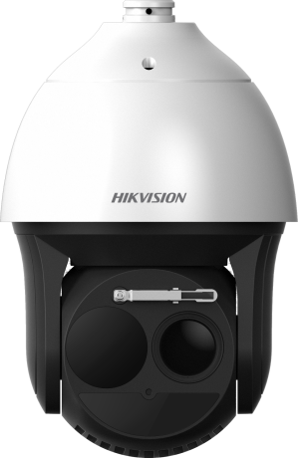

Hikvision DS-2TD4136-25/50 Thermal & Optical Bi-spectrum Network Speed Dome is applied to perimeter defense and fire-prevention purposes in critical infrastructures such as: airport, railway, prison, power station, 4S stores, and so on. The pre-alarm system helps you discover unexpected events immediately and protects you from property loss.

**Smart Function (Thermal Imaging)**

* Leading image processing technology: Adaptive AGC, DDE, 3D DNR, NETD < 40mk (@25°C, F#=1.0)
* Smart tracking: Panorama tracking, Event tracking and Multi-scene patrol tracking
* Smart tracking linkage: thermal view and optical view
* Powerful behavior analysis algorithm: Line crossing, Intrusion, Region Entrance & Exit
* Reliable temperature exception alarm function
* Advanced fire detection algorithm

**Thermal Imaging Module Function**

* 384*288 resolution, high sensitivity sensor, support contrast adjustment
* Support shutter adjustment in various modes
* 3D DNR, 15 palettes of color adjustable, image detail enhancement

  

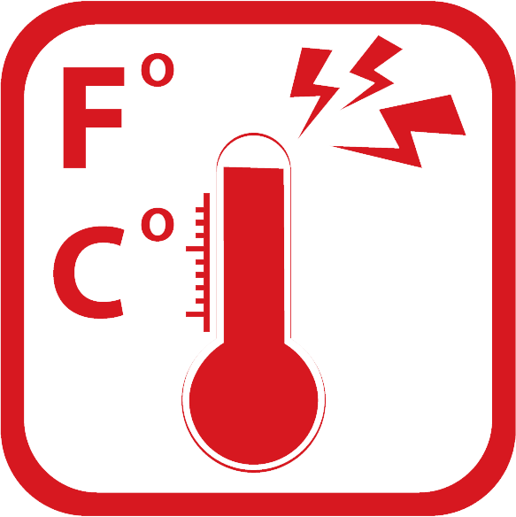 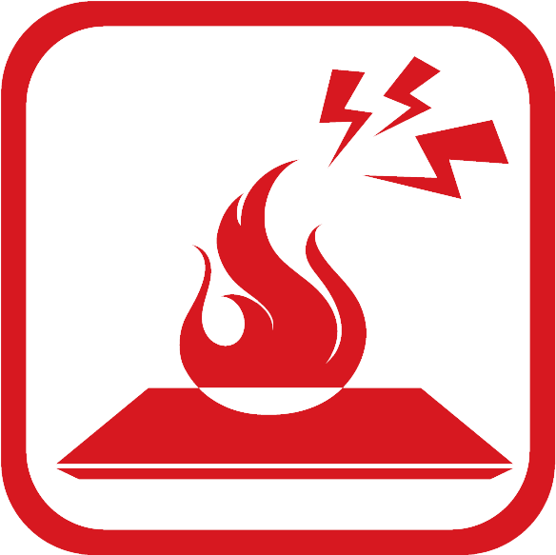 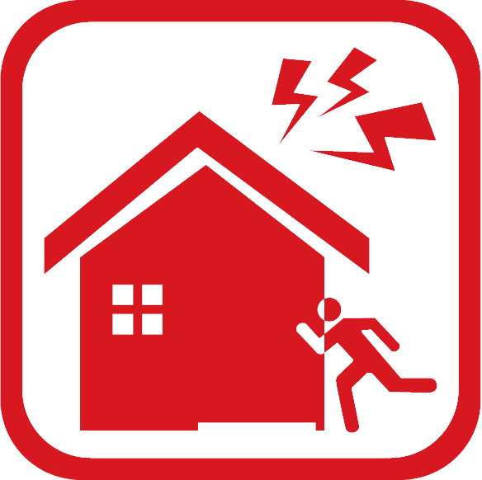 

**Specifications**

| **Model**  **Parameter** | | **DS-2TD4136-25** | **DS-2TD4136-50** |
| --- | --- | --- | --- |
| Thermal & Optical Bi-spectrum Network Speed Dome | |
| **Thermal module** | Image sensor | Vanadium Oxide Uncooled Focal Plane Arrays | |
| Max. Resolution | 384 × 288 | |
| Detector Pitch | 17μm | |
| Response waveband | 8μm to 14μm | |
| NETD | < 40mk (@25°C,F#=1.0) | |
| Lens (focal length) | 25mm | 50mm |
| MRAD | 0.68 | 0.34 |
| Field of View | 15° x 11° | 7.47° x 5.61° |
| Min. Focusing Distance | 1.5 m | 7.5 m |
| F number | 1.0 | |
| **Optical camera** | Image Sensor | 1/1.9’’ Progressive Scan CMOS | |
| Min. Illumination | Color: 0.002 lux @ (F1.5 , AGC On )  B/W : 0.0002 lux @ (F1.5 , AGC On ) | |
| Focal Length | 5.7-205.2mm, 36x | |
| Digital Zoom | 16 X | |
| Field of View | 58.7° - 2.0° (Wide-Tele) | |
| Min. Working Distance | 10-1500mm (Wide-Tele) | |
| Aperture Range | F1.5-F4.5 | |
| Focus Mode | Auto / Semiautomatic / Manual | |
| WDR | 120dB | |
| Shutter Time | PAL: 1-1/30,000s / NTSC: 1-1/30,000s | |
| White Balance | Auto/Manual /ATW/Indoor/Outdoor/Daylight lamp/Sodium lamp | |
| Day & Night | IR Cut Filter | |
| Privacy Mask | 24 privacy masks programmable; optional multiple colors and mosaics | |
| Optical Defog | Yes | |
| Enhancement | 3D DNR | |
| **Smart function** | VCA | Support 4 VCA rule types (Line Crossing, Intrusion, Region Entrance, and Region Exiting), 10 scenes and 8 VCA rules for each scene. | |
| Temperature Measurement | Support 3 temperature measurement rule types, over 256 presets as scene, 21 rules of each scene (10 points, 10 regions, and 1 line) | |
| Temperature range | -20 °C to 150 °C (-4 °C to 302 °F) | |
| Temperature accuracy | ±8 °C (14.4 °F) | |
| Fire detection | Support 10 fire points | |
| **PTZ** | Movement Range | Pan: 360° Continuous Rotate; Tilt: From -15° to + 90° (auto flip) | |
| Pan Speed | Configurable, From 0.1°/s to 160°/s, Preset Speed: 240°/s | |
| Tilt Speed | Configurable, From 0.1°/s to 120°/s, Preset Speed: 200°/s | |
| Proportional Zoom | Yes | |
| Presets | 300 | |
| Patrol Scan | 8; Up to 32 Presets Per Patrol | |
| Pattern Scan | 4; More Than 10 Minutes Per Pattern | |
| Power Off Memory | Yes | |
| Park | Preset/Pattern Scan/Patrol Scan/Auto Scan/Tilt Scan/Random Scan/Frame Scan/Panorama Scan | |
| PT Status | Turn On/Turn Off | |
| Scheduled Task | Preset/Pattern Scan/Patrol Scan/Auto Scan/Tilt Scan/Random Scan/Frame Scan/Panorama Scan/Doom Reboot/Doom Adjust/Aux Output | |
| **Infrared** | IR Distance | Up to 200m | |
| IR Intensity and Angle | Auto Adjust | |
| **Network** | Main Stream | Optical: 50Hz:25fps(1920×1080), 25fps(1280×960), 25fps(1280×720)  Optical: 60Hz:30fps(1920×1080), 30fps(1280×960), 30fps(1280×720)  Thermal: 50fps(384 × 288) | |
| Sub stream | 50Hz:25fps (704 × 576), 25fps (352 × 288), 25fps (176 × 144)  60Hz:30fps (704 × 480), 30fps (352 × 240), 30fps (176 × 120)  Thermal: 50fps (384 × 288) | |
| Video compression | H.264 (Baseline/Main/High Profile) /MJPEG/MPEG4 | |
| Audio compression | G .711u/G.711a/G.722.1/MP2L2/G.726/PCM | |
| Protocols | IPv4/IPv6,HTTP,HTTPS,802.1x,Qos,FTP,SMTP,UPnP,SNMP,DNS,DDNS,NTP,RTSP,RTCP,RTP,TCP,UDP,IGMP,ICMP,DHCP, PPPoE, Bonjourl | |
| Simultaneous live view | Up to 20-ch | |
| User/Host level | Up to 32 users, 3 levels: Administrator, Operator, User | |
| Security measures | User authentication (ID and PW), MAC address binding, HTTPS encryption, IEEE 802.1x access control, IP address filtering | |
| **Integration** | Alarm Input | Up to 7-ch Input (0-5V DC) | |
| Alarm Output | Up to 2-ch Relay Output; Support Alarm Linkage | |
| Alarm Action | Preset/Patrol Scan/Pattern Scan/SD Card Record/Relay Output/Smart capture/FTP upload/Email linkage | |
| Audio Input | LINE_IN Input/MIC Input; Peak: From 2 to 2.4V[p-p]; Output Impedance: 1KΩ±10% | |
| Audio Output | Linear Level; Impedance: 600Ω | |
| Communication Interface | Built-in RJ45; 10M/100M Ethernet Interface | |
| Onboard Storage | Built-in Micro SD/SDHC/SDXC Card Slot, Up to 64GB; Support Manual/Alarm Recording | |
| Analog Video Output | 1.0V [p-p]/75Ω, PAL/NTSC/BNC | |
| RS485 | Half-Duplex; HIKVISION, PELCO-P and PELCO-D Self-adaptive | |
| API | Open-ended API, support ISAPI; Support HIKVISION SDK and Third-party Management Platform | |
| Client | iVMS-4200 | |
| Web Browser | IE 7+, Chrome 18+, Firefox 5.0+, Safari 5.02+; Multiple Languages | |
| **General** | Menu | English | |
| Wiper | Yes | |
| Power | 24V AC, 60W | |
| Work Temperature/Humidity | From -40°C to 60°C (-40°F to 140°F); Humidity: 90% or Less | |
| Protection Level | IP66 Standard; TVS 6000V Lightning Protection, Surge Protection and Voltage Transient Protection | |
| Weight | Approx. 8kg (17.64 lb) | |

**Wide Range Coverage for Different Specifications**

***Note:*** The table below is only for reference, the performance varies from model to model, and the specific data is based on 17 μm detector-pitch.

|  |  |  |  |  |  |  |  |
| --- | --- | --- | --- | --- | --- | --- | --- |
| Lens (focal length) | 7mm | 10mm | 15mm | 25mm | 35mm | 50mm | 75mm |
| Detection range (Vehicles) | 631m | 902m | 1353m | 2255m | 3157m | 4510m | 6765m |
| Detection range (Humans) | 206m | 294m | 441m | 735m | 1029m | 1471m | 2206m |
| Recognition range (Vehicles) | 158m | 225m | 338m | 564m | 789m | 1127m | 1691m |
| Recognition range (Humans) | 51m | 74m | 110m | 184m | 257m | 368m | 551m |
| Identification range (Vehicles) | 79m | 113m | 169m | 282m | 395m | 564m | 846m |
| Identification range (Humans) | 26m | 37m | 55m | 92m | 129m | 184m | 276m |

**Smart functions Range Table**

***Note:*** The table below is only for reference, the performance varies from model to model, and the specific data is based on 17 μm detector-pitch.

|  |  |  |  |  |  |  |  |
| --- | --- | --- | --- | --- | --- | --- | --- |
| Lens (focal length) | 7mm | 10mm | 15mm | 25mm | 35mm | 50mm | 75mm |
| VCA range (humans) | 50m | 72m | 110m | 183m | 255m | 360m | 540m |
| VCA range (Vehicles) | 144m | 205m | 308m | 514m | 720m | 1029m | 1544m |
| Temperature measurement  (Object:2×2 m) | 164m | 234m | 351m | 585m | 819m | 1170m | 1775m |
| Temperature measurement  ((Object:1×1 m) | 83m | 118m | 177m | 295m | 413m | 590m | 885m |
| Fire Detection (Object:2×2 m) | 412m | 588m | 882m | 1470m | 2058m | 2940m | 4410m |
| Fire Detection (Object:1×1 m) | 206m | 294m | 441m | 735m | 1029m | 1470m | 2205m |

**Order Models**

DS-2TD4136-25; DS-2TD4136-50

**Dimensions**



0503071070222

0503071060708