DS-2TD1117-3/P
Thermal Network Turret Camera

 | 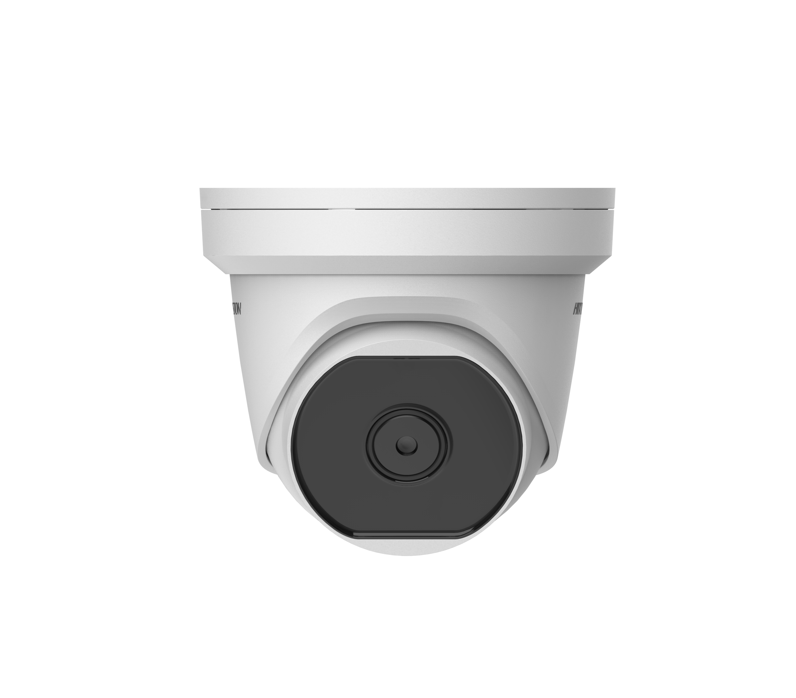

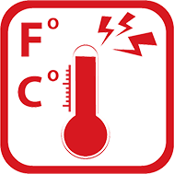 | 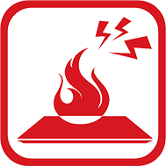 |  |  |  | 

Hikvision DS-2TD1117-3/P Thermal Network Turret Camera equipped with built-in GPU which supports intelligent behavior analysis algorithm, can realize high-precision VCA detection and real-time alarm. It is applied to fire-prevention purposes in indoor space such as engine room, ATM, conference room, warehouse, museum, train station, gem, power station, and so on. The pre-alarm system helps you discover unexpected events immediately and protects your property.
Smart Function (Thermal Imaging)
- Image processing technology: adaptive AGC, DDE, 3D DNR, NETD less than 40 mk (25 °C), F# = 1.1
- Behavior analysis function, based on deep learning algorithm: Line crossing, Intrusion, Region Entrance & Exit
- Temperature exception alarm function
- Fire detection algorithm
Thermal Imaging Module Function
- 160 × 120 (the resolution of output image is 320 × 240) resolution sensor, high sensitivity sensor
- Supports 3D DNR, 15 palettes of color adjustable, image detail enhancement, and contrast adjustment
- Mirror image, digital zoom ×2, ×4, ×8

Specification

Thermal Module
Image Sensor | Vanadium Oxide Uncooled Focal Plane Arrays
Max. Resolution | 160 × 120 (the resolution of output image is 320 × 240)
Pixel Interval | 17 μm
Response Waveband | 8μm to 14μm
NETD | Less than 40 mk (25 °C), F# = 1.1
Lens (Focal Length) | 3.1 mm
IFOV | 5.48 mrad
Field of View | 50° × 37.2° (H × V)
Min. Focusing Distance | 0.2 m
Aperture | F1.1
Smart Function
VCA (Video Content Analysis) | 4 VCA rule types (Line Crossing, Intrusion, Region Entrance, and Region Exiting), up to 8 VCA rules totally.
Temperature Measurement | 3 temperature measurement rule types, 21 rules (10 points, 10 areas, and 1 line).
Temperature Range | -20 °C to +150 °C (-4 °F to +302°F)
Temperature Accuracy | ± 8 °C (± 14.4 °F)
Fire Detection | Dynamic fire point detection, up to 10 fire points detectable.
Network
Main Stream | 1280 × 720, 704 × 576, 640 × 480, 352 × 288, 320 × 240
Sub-Stream | 704 × 576, 352 × 288, 320 × 240
Third Stream | 1280 × 720, 704 × 576, 352 × 288, 320 × 240
Video Compression | H.265/H.264/MJPEG
Audio Compression | G .711u/G.711a/G.722.1/MP2L2/G.726/PCM
Protocols | TCP/IP, ICMP, HTTP, HTTPS, FTP, DHCP, DNS, DDNS, RTP, RTSP, RTCP, PPPoE, NTP, UPnP, SMTP, SNMP, IGMP, 802.1X, QoS, IPv6, UDP, Bonjour
Simultaneous Live View | Up to 20
User/Host Level | Up to 32 users, 3 levels: Administrator, Operator, User
Security Measures | User authentication (ID and PW), MAC address binding, HTTPS encryption, IEEE 802.1x access control, IP address filtering
Integration
Alarm Input | 1-ch inputs (0-5 VDC)
Alarm Output | 1-ch relay outputs, alarm response actions configurable
Alarm Action | SD recording/relay output/smart capture/FTP upload/email linkage
Audio Input | 1, 3.5 mm Mic in/Line in interface. Line input: 2-2.4 V [p-p], output impedance: 1KΩ ± 10%
Audio Output | Linear level, impedance: 600 Ω
Reset | 1 Reset Button
Communication Interface | 1, RJ45 10M/100M self-adaptive ethernet interface. 1, RS-485 interface
SD Memory Card | Built-in Micro SD card slot, support Micro SD/SDHC/SDXC card (up to 256G), support manual/alarm recording
Analog Video Output | 1.0 V [p-p]/75 Ω, PAL/NTSC
Application Programming | Open-ended API, supporting ISAPI, HIKVISION SDK, and third-party management platform
Client | iVMS-4200, Hik-Connect
Web Browser | IE9+, chrome31-44, Firefox 30-51, Safari 5.02+ (mac)
General
Menu Language | 32 languages  English, Russian, Estonian, Bulgarian, Hungarian, Greek, German, Italian, Czech, Slovak, French, Polish, Dutch, Portuguese, Spanish, Romanian, Danish, Swedish, Norwegian, Finnish, Croatian, Slovenian, Serbian, Turkish, Korean, Traditional Chinese, Thai, Vietnamese, Japanese, Latvian, Lithuanian, Portuguese (Brazil)
Adjustment Range | Pan: 0° to 360°, Tilt: 0° to 75°, Rotate: 0° to 360°
Power | 12 VDC ± 20%, two-core terminal block  PoE (802.3af, class 3)
Power Consumption | 12 VDC ± 20%: 0.4 A, max. 4.5 W  PoE (802.3af, class 3): 42.5 V to 57 V, 0.14 A to 0.22 A, max. 5 W
Working Temperature/Humidity | -40 °C to 65 °C (-40 °F to 149 °F)  95% or less
Protection Level | IP66 Standard, TVS 6000V lightning protection, surge protection, voltage transient protection
Dimensions | 138.3 mm × 138.3 mm × 123.1 mm (5.45 " × 5.45" × 4.85 ")
Weight | 920 g (2.03 lb)

Detection Range Table
* The table is only for reference, and the performance may vary from camera to camera.
Smart Functions Range
Different targets trigger the VCA events within different range limits.

VCA Range (Vehicles: 1.4 × 4.0 m) | VCA Range (Humans: 1.8 × 0.5 m) | Temperature Measurement (Object: 2 × 2 m) | Temperature measurement (Object: 1 × 1 m) | Fire Detection (Object: 2 × 2 m) | Fire Detection (Object: 1 × 1 m)
63 m | 21 m | 66 m | 33 m | 180 m | 90 m

Wide Range Coverage
There is range limit for detecting, recognizing, and identifying human/vehicle targets.

Detection Range (Vehicles: 1.4 × 4.0 m) | Detection Range (Humans: 1.8 × 0.5 m) | Recognition Range (Vehicles: 1.4 × 4.0 m) | Recognition Range (Humans: 1.8 × 0.5 m) | Identification Range (Vehicles: 1.4 × 4.0 m) | Identification Range (Humans: 1.8 × 0.5 m)
280 m | 91 m | 70 m | 23 m | 35 m | 11 m

Available Model
DS-2TD1117-3/P
Dimension

